Original article:
Gorlin Goltz syndrome- Report of 2 cases
Dr. Shilpa J Parikh ¹, Sheetal Sharma², Jigna. S. Shah³, Dr. NehaKharodia⁴

¹Professor, Dept. Of Oral Medicine & Radiology, Government Dental College &Hospital,Ahmedabad (Gujarat).
²P.G student, Dept. Of Oral Medicine & Radiology, Government Dental College & Hospital, Ahmedabad(Gujarat).
³Professor & head, Dept.Of Oral Medicine & Radiology, Government Dental College &Hospital,Ahmedabad (Gujarat).
⁴P.G student, Dept.Of Oral Medicine & Radiology, Government Dental College & Hospital, Ahmedabad (Gujarat).
Corresponding Author: Dr.Sheetal Sharma

Abstract:
Gorlin-Goltz syndrome (GGS) also known as nevoid basal cell carcinoma syndrome is a rare autosomal dominant disorder characterized by a wide spectrum of developmental anomalies and neoplasms. The syndrome is caused by mutations in patched, a tumor suppressor gene located 9q22.3. A single point mutation in one patched allele may be responsible for the malformations and their variability in the syndrome patients. Inactivation of both alleles results in the formation of tumors and cysts, such as BCC, OKC, and medulloblastoma. Here we report 2 cases of Gorlin-Goltz syndrome who presented with complain of swelling, patients were treated by different modalities based on the analysis separately. Cases were kept on long term follow up to monitor the recurrence of treated cysts or development of basal cell carcinoma.
Keywords: Gorlin Goltz syndrome, multiple odontogenic keratocysts, syndromic multiple cysts.

INTRODUCTION
The Gorlin-Goltz syndrome, also known as nevoid basal cell carcinoma syndrome (NBCCS), is an inherited autosomal dominant systemic disorder having versatile manifestations.^{[1]} This syndrome has received several names throughout the times such as, basal cell nevus syndrome, multiple NBCCS, multiple basal cell carcinoma syndrome, multiple basalioma syndrome, jaw cysts basal cell tumor, skeletal anomalies syndrome and odontogenic keratocysts skeletal anomalies syndrome. ^{[2]}It is also called as the fifth phakomatosis due to the presence of multiple cutaneous, skeletal, ophthalmic and neurological abnormalities. It comprises of skeletal features such as the bifid rib, frontal and parietal bossing and mandibular prognathism and cutaneous abnormalities such as multiple basal cell carcinomas and palmar and plantar keratosis. NBCCS can also include concomitant hypertelorism, mental retardation, strabismus, calcification of the falx cerebri and medulloblastomas. ^{[3]}
It is caused by a tumor suppressing gene called ‘patched’ gene found in the long arm of a chromosome 9q22.3-q31 which controls growth and development of normal tissues. Deactivation of both allele causes formation of tumors and cysts, like KCOT, basal cell carcinoma and medulloblastoma. ^{[1,2]} Here we report 2 cases of gorlin goltz syndrome who presented with complain of swellings.

CASE REPORT
TABLE -1
 | CASE 1 | CASE 2
Complaint | Swelling on left posterior tooth region since15 days. | Pain and swelling on left posterior tooth region since1 month along with pus discharge from last 2 days
Age | 30 years | 25 years
Sex | Female | Male
Extraoral features | No significant extraoral features seen. [Fig 1a] | No significant extraoral features seen. [Fig 1b]
Intraoral presentation | 1) A single ill-defined hard, non-tender, non-compressible, non-fluctuant swelling with no expansion of buccal and lingual cortical plate was presentin edentulous region of 36,37,38.  2)Other findings-generalized spacing between all lower teeth. Rotation of crown of 31,32 and 33 was present.[Fig 2a] | 1) A single well definedhard, non-tender, non-compressible, non-fluctuant swelling with expansion present in region of 36,37, 38  2) Pus discharge present from left lower third molar region.3) Other findings-Clinically missing 18,28,38,48 distobuccally tilted 37, lingually tipped 47. [Fig 2b]
Provisional diagnosis | Dentigerous cyst irt 38, ameloblastoma and Kcot
Radiographic features
IOPA | Well defined multiple multilocular radiolucency with corticated borders seen in all four quadrants with no resorption of involved teeth. | Well defined multiple multilocular radiolucency seen with missing third molar in all four quadrants along with root resorption of adjacent tooth.
Occlusal[ cross sectional radiograph] | No expansion seen. | showed buccal cortical plate expansion in mandibular left posterior teeth region.
Orthopentomograph | Well defined multiple radiolucency seen in all four quadrants. [Fig 3a] | Well defined multiple radiolucency seen in all four quadrants with superior displacement of 18 and 48. [Fig 3b]
PA skull, lateral skull,PNS | Showed calcification of the falx cerebri. [Fig 4a] | Showed calcification of the falx cerebri. [Fig 4b]
Chest x-ray | - | Shows 4th and 5th bifid ribs. [Fig 5]
Hand wrist radiograph | Normal metacarpals of both the hands. | Normal metacarpals of both the hands.
Ct scan | multiple well defined expansile, non-enhancing fluid density lesion seen over bilateral maxilla, right mandibular ramus and left mandibular body.  2) Anterior and posterior falx and tentorial calcification present.  3) Well defined fusiform, minimally enhancing lesion arising from left optic nerve in retro bulbar portion may represent optic nerve glioma. | Multiple expansile lytic-cystic odontogenic lesions involving body and ramus of mandible and posterior maxilla bilaterally.  2) Falx cerebri and tentorial calcification seen.
Fluid aspirated | cheesy white fluid | cheesy white fluid
Treatment | marsupialization of all cysts with treatment with carnoy’s solution was done. | complete enucleation of all cysts with removal of 26, 27,36,37,47 and impacted 3rd molars.
H/P | Epithelial lining is 5-6 layer thick with basal palisading and surface is covered by parakeratin with dysplastic changes. | Epithelial lining is 4-5 layer thick with basal palisading and surface is covered by parakeratin.
Follow up | 6months follow shows no recurrence and bone formation. [Fig 6a] | 2months follow shows no recurrence. [fig 6b]

DISCUSSION
Gorlin-Goltz syndrome was described for the first time in 1894 by Jarisch and White.Global signs and symptoms associated with this syndrome were described in detail by Robert Gorlin and Robert Goltz in 1960, after which the condition became to be known as Gorlin-Goltz syndrome (GGS). ^{[1,5]} It is a rare syndrome with a prevalence varying from 1/57,000 to 1/256,000 people.Syndrome is usually seen in 2nd to 3rd decade of life with equal prevalence in both the sex, usually presenting with the complaint of swelling. ^{[1, 5, 6]} Both the reported cases were presented in 2-3 decade,out which one was female and other was male with complaint of painless swelling. Based on history, siteand age, provisional diagnosis of dentigerous cyst was made with differential diagnosis, ameloblastoma and kcot was considered. On radiographic examination ,multiple multilocular cystic lesions were seen in all four quadrants, with minimal expansion as kcot grows in anterior-posterior direction. Thus, possibility of Gorlin Goltz syndrome and Maroteaux Lamy syndrome were considered. ^{[1,7]} Since Maroteaux- Lamy syndrome patients present with characteristic facial features consisting of a large head, short neck, corneal opacity, open mouth with an enlarged tongue, enlargement of skull, and a long anterior-posterior dimension. Thus, radiographically the cases were more in favor of Gorlin Goltz syndrome. For confirmation, various other radiographic investigations i.e. PA skull, chest X- ray, CT scan and FNAC were carried out which showed falx cerebri, tentorial calcification and bifid rib. On the basis of these findings a diagnosis of Gorlin-Goltz syndrome was made in both the cases. ^{[1,7]} In our reported, case 1 had left optic nerve glioma on CT examination but clinically patient didn’t present with balance problems, vision disturbances, headache, involuntary eye movements and memory impairment.
The diagnostic criteria were originally defined by Evanset al in 1993 and later modified by Kimonis et al in 1997 and Bree et al in 2011.^{[1,3,4,5]}The Major criteria includes excessive numbers of basal cell carcinomas out of proportion with prior sun exposure and skin type or < 20 years of age, odontogenic keratocyst of the jaws prior to 20 years of age, palmar or plantar pitting, lamellar calcification of the falxcerebri, medulloblastoma (typically desmoplastic), 1st degree relative with gorlin-goltz syndrome and the minor criteria are rib anomalies, other specific skeletal malformations and radiologic changes (i.e. vertebral anomalies, kyphoscoliosis, short 4th metacarpals, postaxial polydactyly, macrocephaly, cleft lip and/or palate, ovarian/cardiac fibroma, lymphomesenteric cysts , ocular abnormalities. Diagnosis of gorlin-goltz syndrome can be made in the presence of: 2 major criteria or 1 major criteria and molecular confirmation or 1 major and 2 minor criteria. ^{[1-5]}

The major and minor criteria found in our cases are mentioned below in table 2-
TABLE 2
MAJOR CRITERIA | CASE 1 | CASE 2
basal cell carcinomas | - | -
Odontogenic keratocysts of the jaws prior to 20 yrs of age | ++ | ++
Palmar or plantar pitting | - | -
Lamellar calcification of the falxcerebri | ++ | ++  61
Medulloblastoma | - | -
MINOR CRITERIA
Rib anomalies | - | ++
Other specific skeletal malformations and radiologic changes | - | -
short 4th metacarpals | - | -
Macrocephaly, Cleft lip and/or palate, Ovarian/cardiac fibroma, Lymphomesenteric cysts, Ocular abnormalities | -

The treatment of NBCCS is the basedon its clinical manifestations.
There are two ways of management i.e. conservative and aggressive (N.K Kiran et al.2012). ^{[8]} In the conservative method, simple enucleation with or without curettage and marsupialization are suggested.
The aggressive method includes include peripheral otectomy, chemical curettage with Car-noy's solution and resection with recurrence rate of 60% after surgical excision of lesion. ^{[2,6,9]}Both the reported cases, were treated with conservative method to prevent recurrence.
Histopathological examination of OKC shows cystic lining overlying the connective tissue
capsule. The lining epithelium was of layers thick. The basal layer showed hyperchromatism and palisading appearance. The surface was corrugated and showed pyknotic nuclei, the epithelium was folded and showed separation from the capsule in many areas.Both the cases showed similar features. ^{[1, 3, 5]}
Radical interventions as enucleation with shaving of surrounding bone or sometime resection might contribute to preventing recurrences and to improve the prognosis. ^{[3,7,8]}
CONCLUSION
Gorlin Goltz Syndrome is an interesting lesion for the dentist who is often the first clinician involved in the diagnosis of this syndrome. Because of the multisystem involvement and variable expressivity of NBCCS, patients affected by the disorder must be evaluated by many medical and dental specialists in order to properly sequence their treatment. These patients should be kept on long term follow up as these patients are predisposed for developing basal cell carcinoma with high recurrence rate also its transmission is autosomal dominant with good penetrance implies the need of genetic counselling.

REFERENCES
- Sunder, Suresh Babburi, Srikanth Guduguntla. Gorlin-goltz syndrome: a rare case report Journal of Dr. Ntr University of Health Sciences 2013;2(2): 150-153.
62
- Barkha N, Biswajeet, Ajit M, Deepak T.Gorlin-Goltz Syndrome. Journal of Indian Academy of Oral Medicine and Radiology, July-September 2011;23(3): S487-490.
- Freny Karjodkar, Shobhit K Garg. Gorlin-Goltz Syndrome – Case Report.Journal of Clinical and Diagnostic Research. 2011 Apr, Vol-5(2):393-395.
- Acharya S, Panda S, Dhull KS, Sahoo SR, Ray P. Gorlin syndrome with bilateral polydactyly- a rare case report. Int J Clin Pediatr Dent 2013;6(3):208-212.
- Anne Kristine Larsen, Dorthe Bisgaard Mikkelsen, Jens Michael Hertz& Anette Bygum. Manifestations of Gorlin-Goltz Syndrome.Dan Med J May 201461/5.
- Lorenzo Lo Muzio. Nevoid basal cell carcinoma syndrome-review. Orphanet Journal of Rare Diseases 2008, 3:32.
- Ali Rıza Alpo,Mahmut Coker, Elif Celen, Nazan Kocatas Ersin, Damla Gokcen,Otto P. van Diggelenc et al. The oral manifestations of Maroteaux-Lamy syndrome (mucopolysaccharidosis VI): A case report. oooE; volume 101.number-5.
- K. Kiran, T. N. Tilak Raj, K. S. Mukunda, and V. Rajashekar Redd.Nevoid Basal Cell Carcinoma Syndrome.Contemp Clin Dent. 2012 Oct­Dec; 3(4): 514–518.

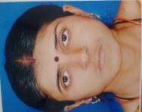


Fig 1b: showing extraoral profile
Fig a1: showing extraoral profile
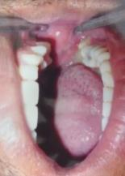
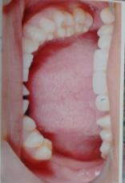

Fig 2b-intraoral clinical picture of case 2 showing a ill -defined swelling in relation to 38 region

Fig 2a-intraoral clinical picture of case 2 showing a ill -defined swelling in relation to 36-38 region

63
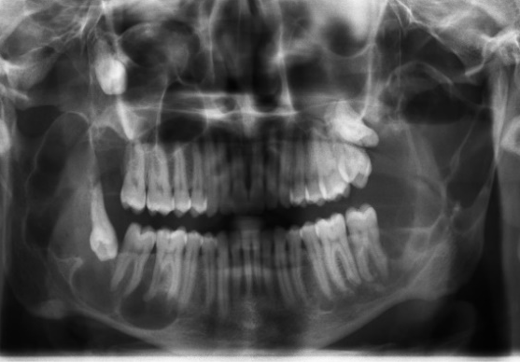
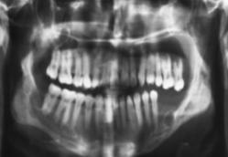

Fig 3b-opg showed preoperative opg showing multiple well defined multilocularradioluncency in all 4 posterior quardent
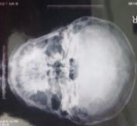
Fig 3a - Preoperativeopg showing multiple well defined multilocularradioluncency in all 4 posterior quaderent

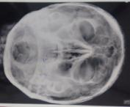
fig 4a: showingcalcification of the falxcerebri.
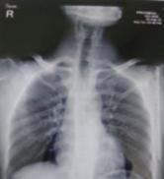
Fig 5: case 2showingbifid rib.

Fig 4b: showingcalcification of the falxcerebri.

64
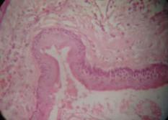
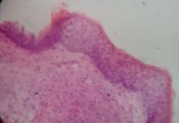

Fig 6b: Photomicroscopic photograph showing epithelial lining is 4-5 layer thick with basal palisading and surface is covered by parakeratin. (40xh&e)
Fig 6a: Photomicroscopic photograph showing epithelial lining is 5-6 layer thick with basal palisading and surface is covered by parakeratinwith dysplastic changes. (40xh&e)

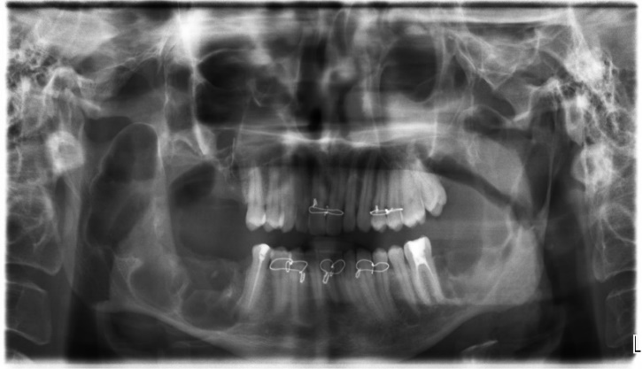
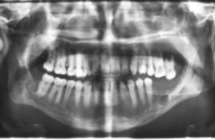
Fig 6b: Post-operative OPG 2months follow up shows root canal treated enucleated region in all four quadrant. Intentional root canal treated 47,35 with interdental wiring

Fig7a: Post-operative OPG of case 1showed enucleated region in all four quadrant.

65
TABLE -1
 | CASE 1 | CASE 2
Complaint | Swelling on left posterior tooth region since15 days. | Pain and swelling on left posterior tooth region since1 month along with pus discharge from last 2 days
Age | 30 years | 25 years
Sex | Female | Male
Extraoral features | No significant extraoral features seen. [Fig 1a] | No significant extraoral features seen. [Fig 1b]
Intraoral presentation | 1) A single ill-defined hard, non-tender, non-compressible, non-fluctuant swelling with no expansion of buccal and lingual cortical plate was presentin edentulous region of 36,37,38.  2)Other findings-generalized spacing between all lower teeth. Rotation of crown of 31,32 and 33 was present.[Fig 2a] | 1) A single well definedhard, non-tender, non-compressible, non-fluctuant swelling with expansion present in region of 36,37, 38  2) Pus discharge present from left lower third molar region.3) Other findings-Clinically missing 18,28,38,48 distobuccally tilted 37, lingually tipped 47. [Fig 2b]
Provisional diagnosis | Dentigerous cyst irt 38, ameloblastoma and Kcot
Radiographic features
IOPA | Well defined multiple multilocular radiolucency with corticated borders seen in all four quadrants with no resorption of involved teeth. | Well defined multiple multilocular radiolucency seen with missing third molar in all four quadrants along with root resorption of adjacent tooth.  66
Occlusal[ cross sectional radiograph] | No expansion seen. | showed buccal cortical plate expansion in mandibular left posterior teeth region.
Orthopentomograph | Well defined multiple radiolucency seen in all four quadrants. [Fig 3a] | Well defined multiple radiolucency seen in all four quadrants with superior displacement of 18 and 48. [Fig 3b]
PA skull, lateral skull,PNS | Showed calcification of the falx cerebri. [Fig 4a] | Showed calcification of the falx cerebri. [Fig 4b]
Chest x-ray | - | Shows 4th and 5th bifid ribs. [Fig 5]
Hand wrist radiograph | Normal metacarpals of both the hands. | Normal metacarpals of both the hands.
Ct scan | multiple well defined expansile, non-enhancing fluid density lesion seen over bilateral maxilla, right mandibular ramus and left mandibular body.  2) Anterior and posterior falx and tentorial calcification present.  3) Well defined fusiform, minimally enhancing lesion arising from left optic nerve in retro bulbar portion may represent optic nerve glioma. | Multiple expansile lytic-cystic odontogenic lesions involving body and ramus of mandible and posterior maxilla bilaterally.  2) Falx cerebri and tentorial calcification seen.
Fluid aspirated | cheesy white fluid | cheesy white fluid
Treatment | marsupialization of all cysts with treatment with carnoy’s solution was done. | complete enucleation of all cysts with removal of 26, 27,36,37,47 and impacted 3rd molars.  67
H/P | Epithelial lining is 5-6 layer thick with basal palisading and surface is covered by parakeratinwith dysplastic changes. | Epithelial lining is 4-5 layer thick with basal palisading and surface is covered by parakeratin.
Follow up | 6months follow shows no recurrence and bone formation. [Fig 6a] | 2months follow shows no recurrence. [fig 6b]

The major and minor criteria found in our cases are mentioned below in table 2-
TABLE 2
MAJOR CRITERIA | CASE 1 | CASE 2
basal cell carcinomas | - | -
Odontogenic keratocysts of the jaws prior to 20 yrs of age | ++ | ++
Palmar or plantar pitting | - | -
Lamellar calcification of the falxcerebri | ++ | ++
Medulloblastoma | - | -
MINOR CRITERIA
Rib anomalies | - | ++
Other specific skeletal malformations and radiologic changes | - | -
short 4th metacarpals | - | -
Macrocephaly, Cleft lip and/or palate, Ovarian/cardiac fibroma, Lymphomesenteric cysts, Ocular abnormalities | -
68

